- MAJOR FIELDS
- Geo incorrect/non-city level (agent saved or did not improve):
When verifying a Geo, remember to verify information according to the following hierarchy:
Official Website > Provider Page (OTA) > Social Media > Google Listing
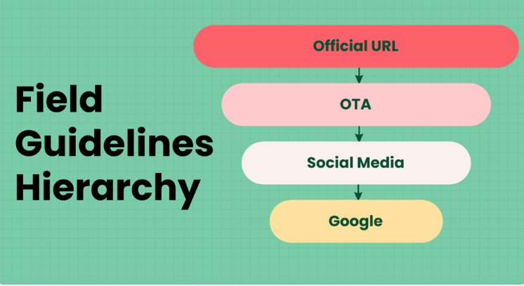
Always prioritize the highest available source in the hierarchy.
Note: This hierarchy does not apply to the Policy Geo Team, while working on Salesforce cases and geo-related cases.

2. INVALID ACTION
- Rejected eligible listing (new listing)
First, review the provider page and check the available room options. If the room options are unclear , refer to the property description and look for any indications that the property offers multiple units. If it is still unclear or not bookable unable to verify accurately.
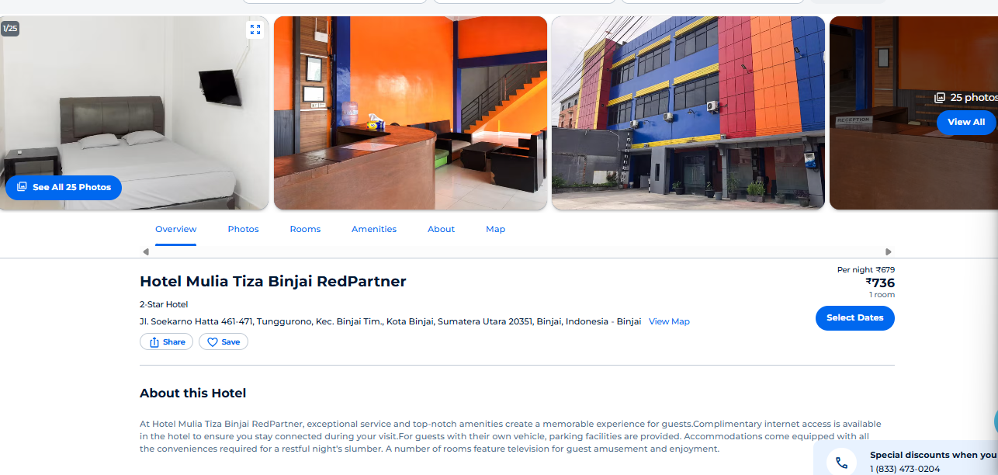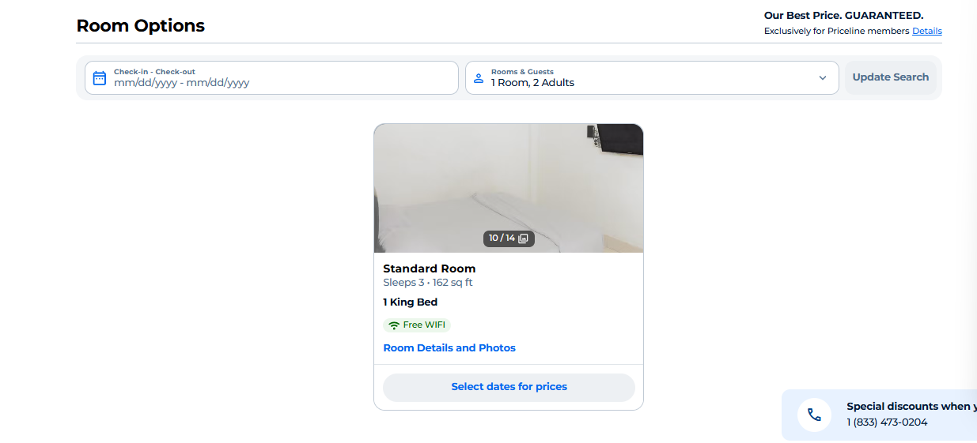
Check other OTAs to review the room options and description that the property offers multiple units. You can also try changing the dates to see if additional room options become available.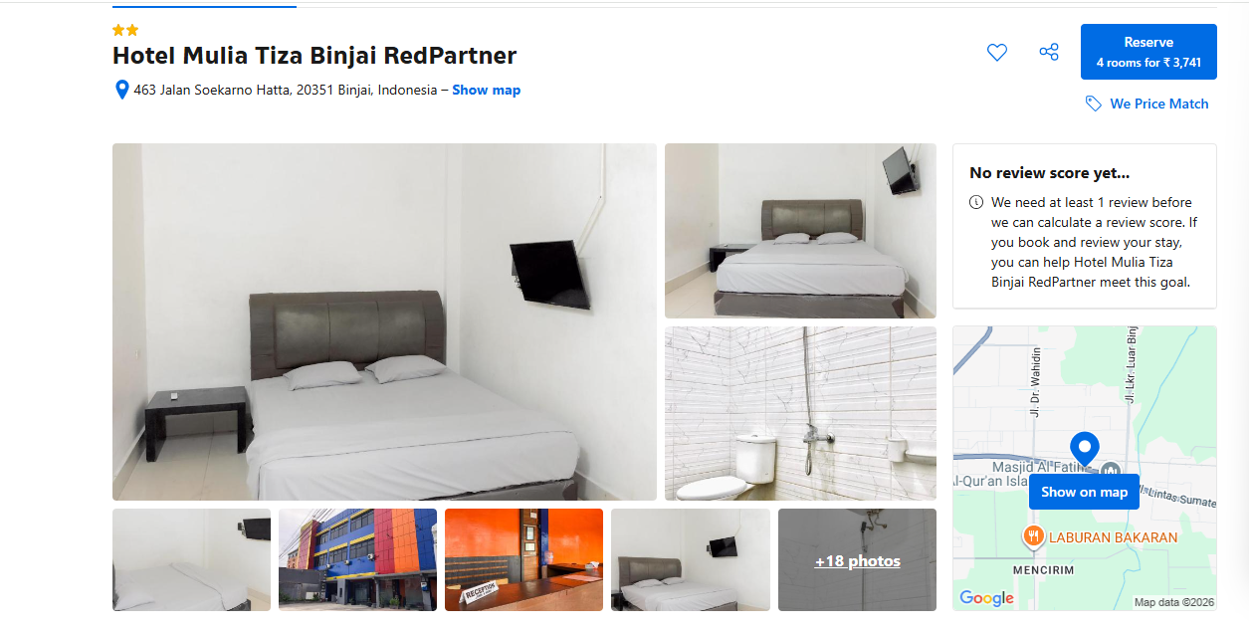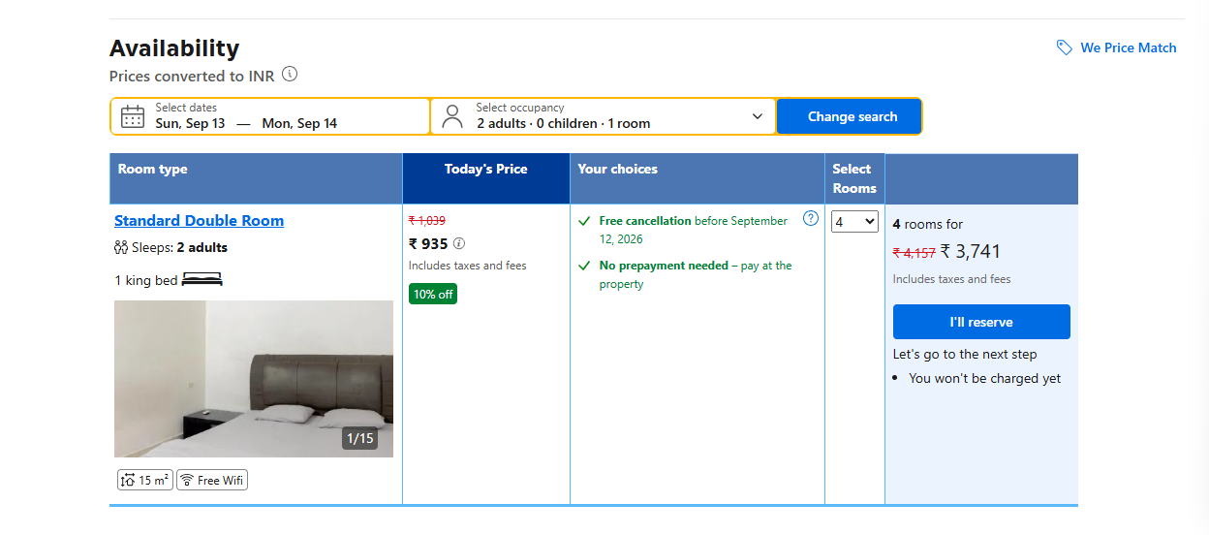

3. MISSED DETAILS
- Phone number not added when available (New Listings: candidates, commerce, match) (not part of the request)
- Email not added when available (New Listings: candidates, commerce, match) (not part of the request)
- URL not added when available (New Listings: candidates, commerce, match) (not part of the request)
When there is no Google listing available for the property, first check the provider page to determine whether a Google listing exists for the property. Review the map provided on the provider page, zoom in to the property's location, and click on Google. This will redirect you to Google Maps, where you can verify if a Google listing exists for the property. If a Google listing is available, you can use the details from it for accurate verification and geo mapping.
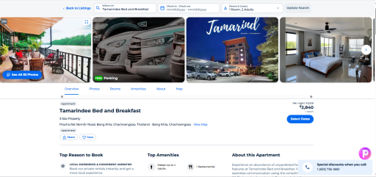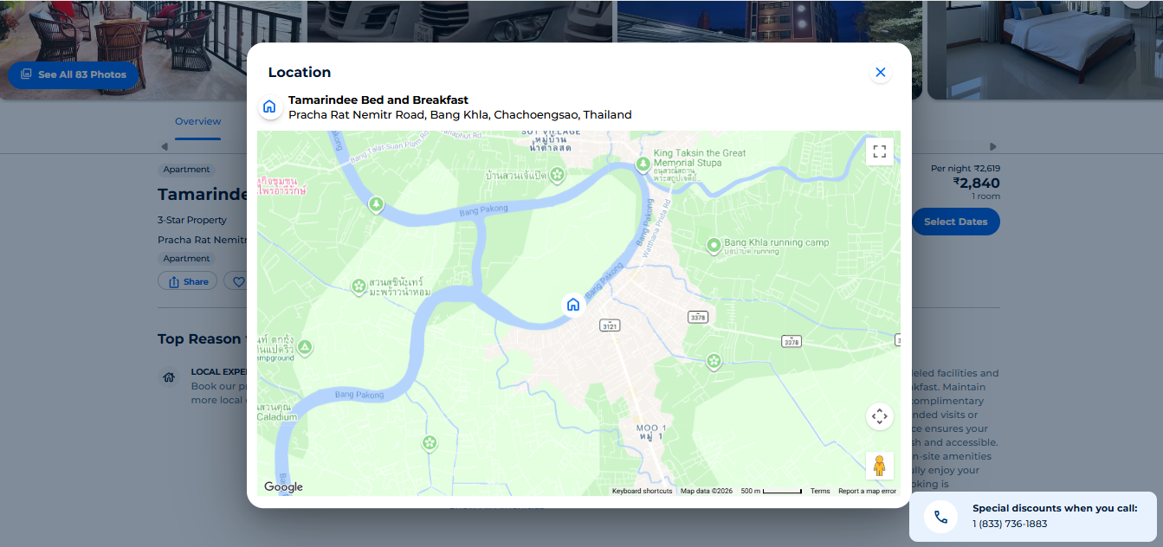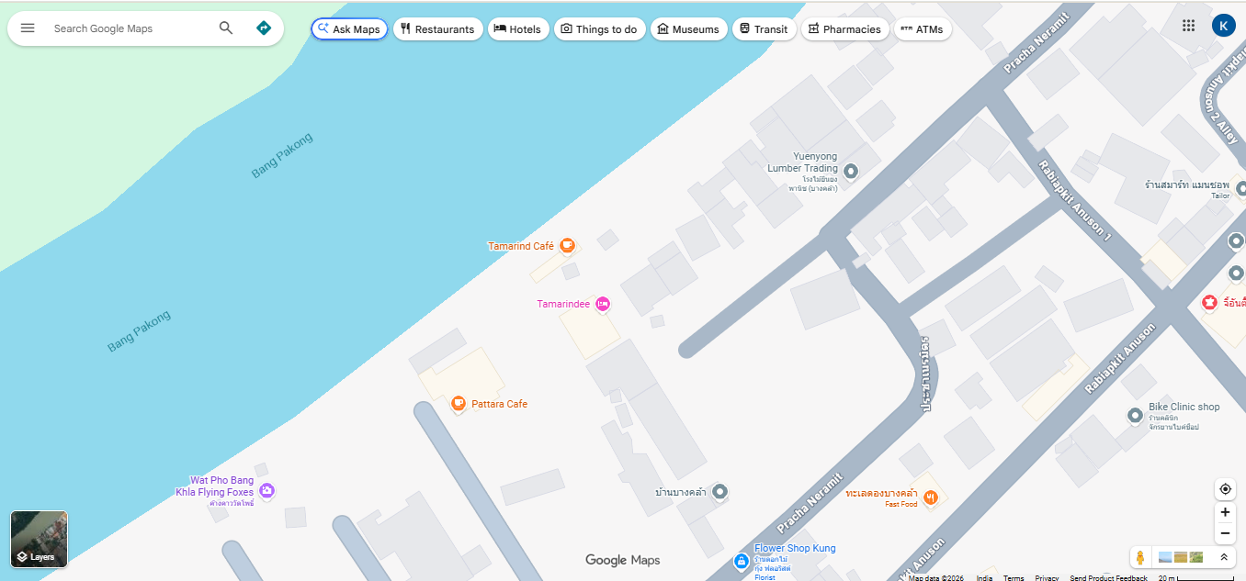
Click on our property to see details, Google listing will pop up and you can take website, phone number, email… etc from here 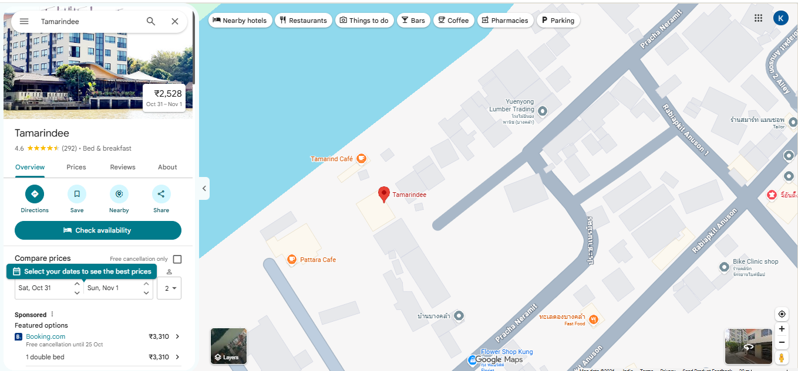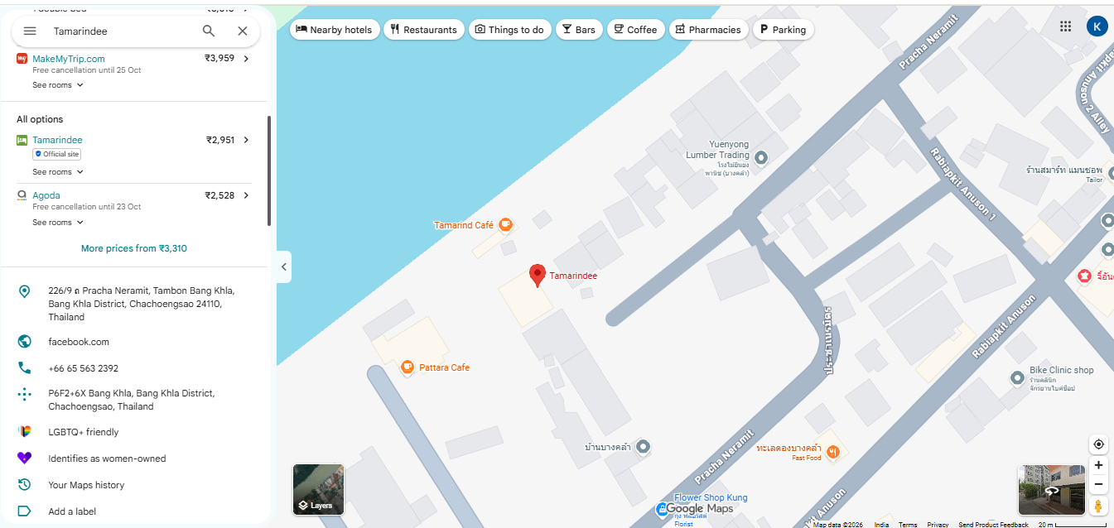

When a Google listing is not directly available, utilize the provider page map to identify the google lisitng this is how you can find the google listing through the provider page
Policy Updates
Closed Flowchart Update:
Multiple mentions of closure in TA, Google, Yelp, Zomato, Foursquare, etc. (or equivalent 3rd party sites) reviews
Accommodation type:
In South Korea ONLY, we will now list any accommodation that includes "Pension" in their business name under the Pension accommodation type
Examples:
- "Pension Manoa" = Apply Pension type
- "Daegwallyeong Areumdaun Pension" = Apply Pension type
Car rentals :
If the business offering car rentals along with the AIRPORT TRANSFERS we can tag it under “Taxis & Shuttles”
Note : Do not list rental car companies that exclusively provide car rental services only, unless they specifically offer luxury car rentals.

Geo research guidelines:
In Google Maps, place names shown in small, ALL-CAPS lettering might already have geos in our system. Cross-check them against the live TripAdvisor site to confirm the geo's existence and make any necessary updates.
Examples:
- Kondapur
- Madhapur
If our property is falling under any such specific geo’s cross-check them against the live TripAdvisor site
